**Now performing Analysis using Gephi Tool:**

In Gephi, when importing the "hashtags_edges.csv" file, you should select it as an "Edges Table."

Here's a step-by-step guide on how to do it:

* Open Gephi and create a new project.
* In the "Data Laboratory" tab, click on the "Import Spreadsheet" button.
* Select the "hashtags_edges.csv" file.
* In the import options:
* Choose "Edges Table" as the data type.
* Ensure that the separator is set to comma (,).
* Check the box for "First Row as Column Titles."
* Ensure that the appropriate columns are mapped to Source and Target columns, representing the connections between hashtags.
* Click "Next" and then "Finish" to import the CSV file as an edge list into Gephi.
* Follow same steps for importing for hashtag_nodes.csv
* Choose Nodes table as the type.
* Ensure the columns are correctly mapped that is source and target.
* Click Next and then Finish.
* After importing both the nodes and edges tables, your graph should be visible in Gephi. If the graph is still not visible, try applying a layout from the Layout tab, such as ForceAtlas2, to visualize the network.
* Gephi will create a network visualization based on the imported data. You can customize the visualization settings and layout as needed.

Here are the screenshots to perform the above steps:

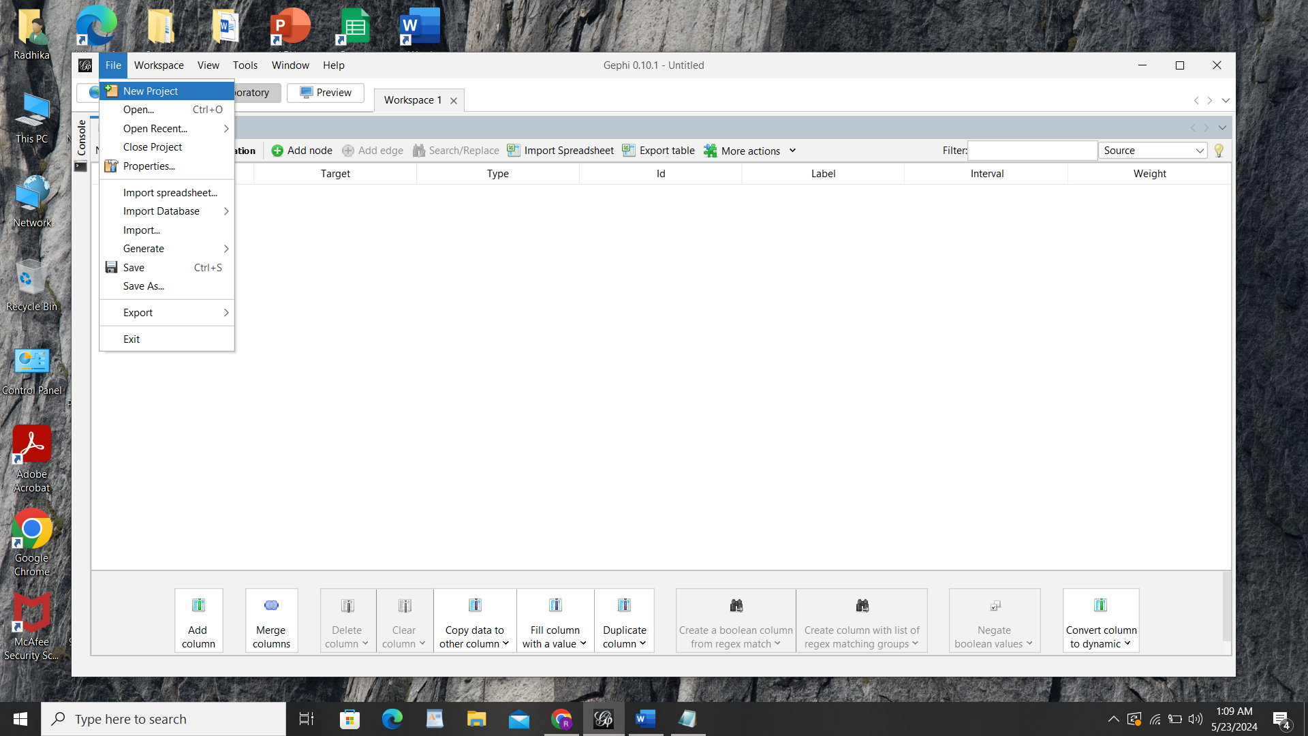

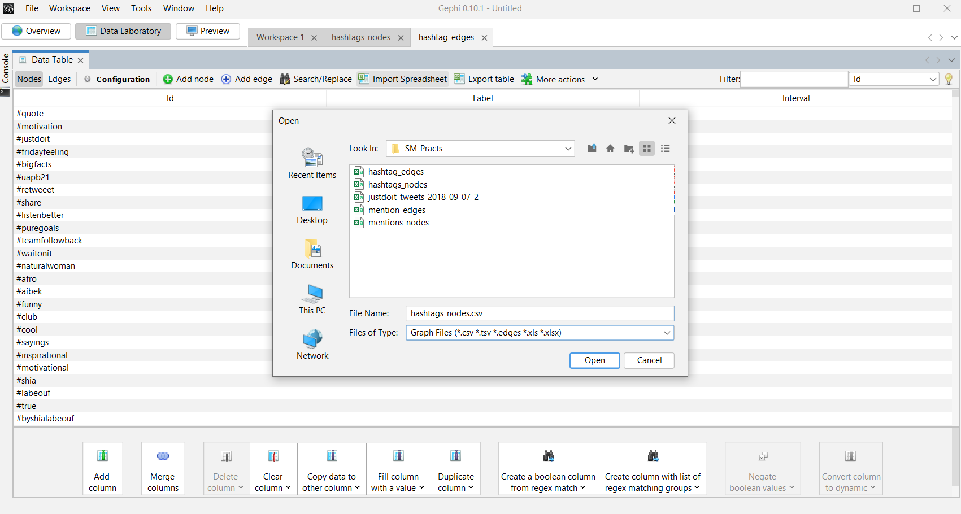

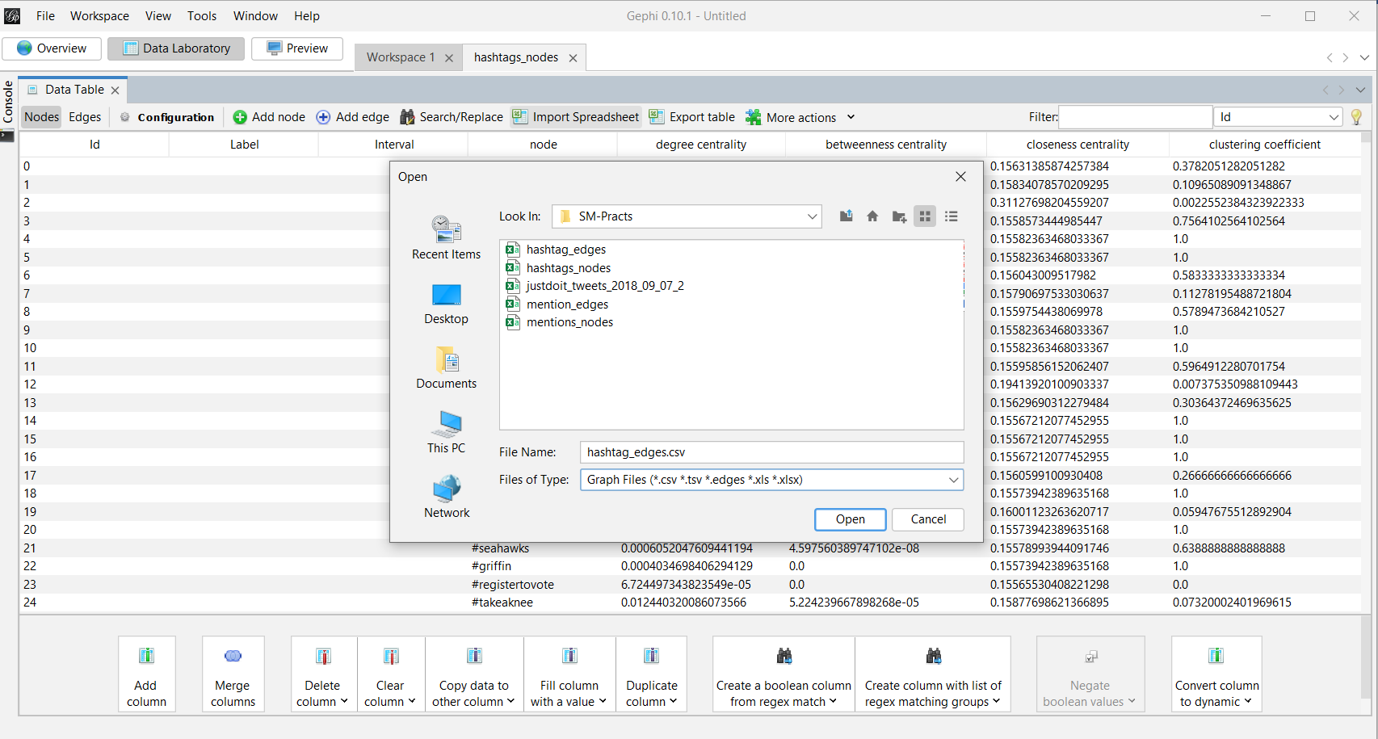

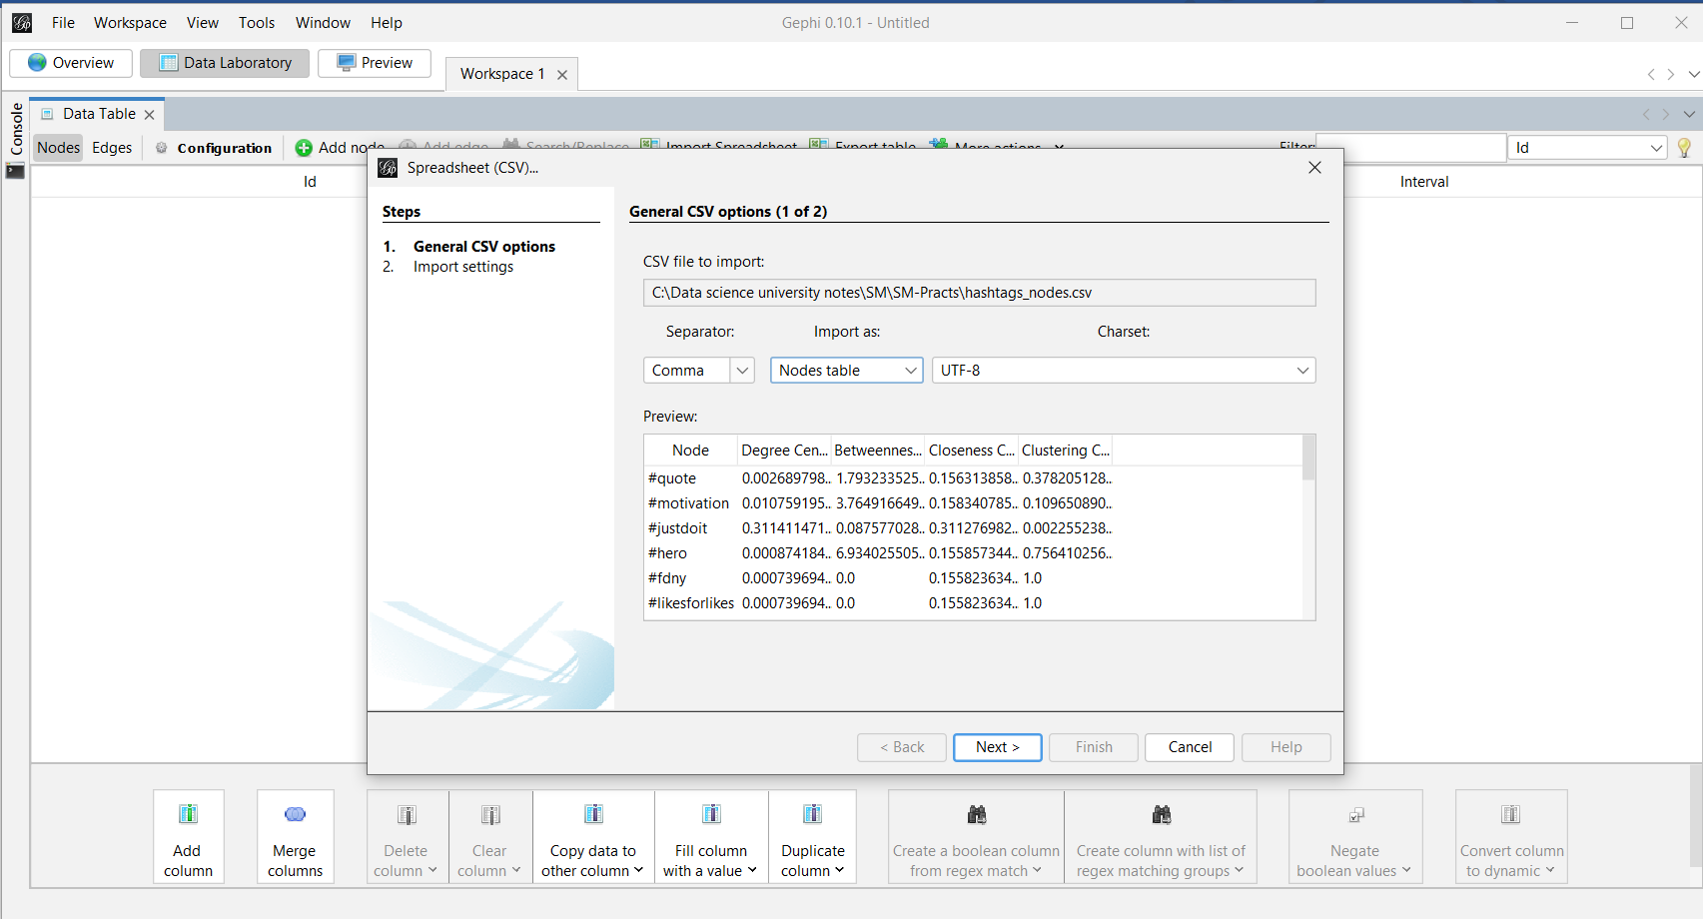

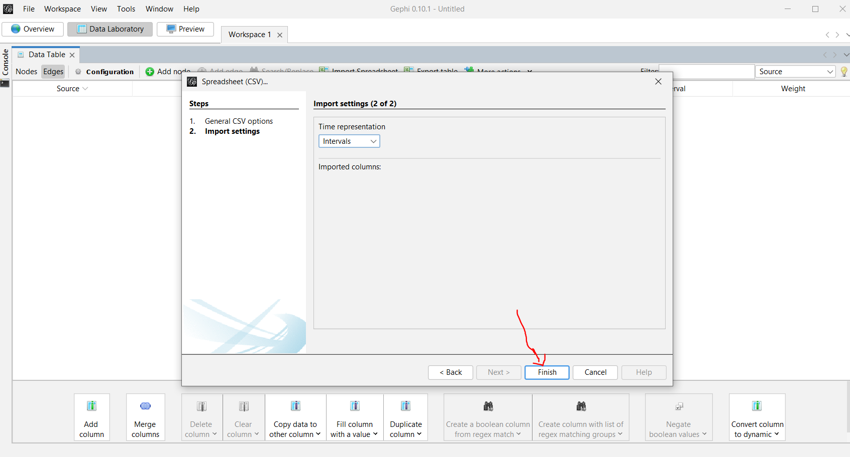

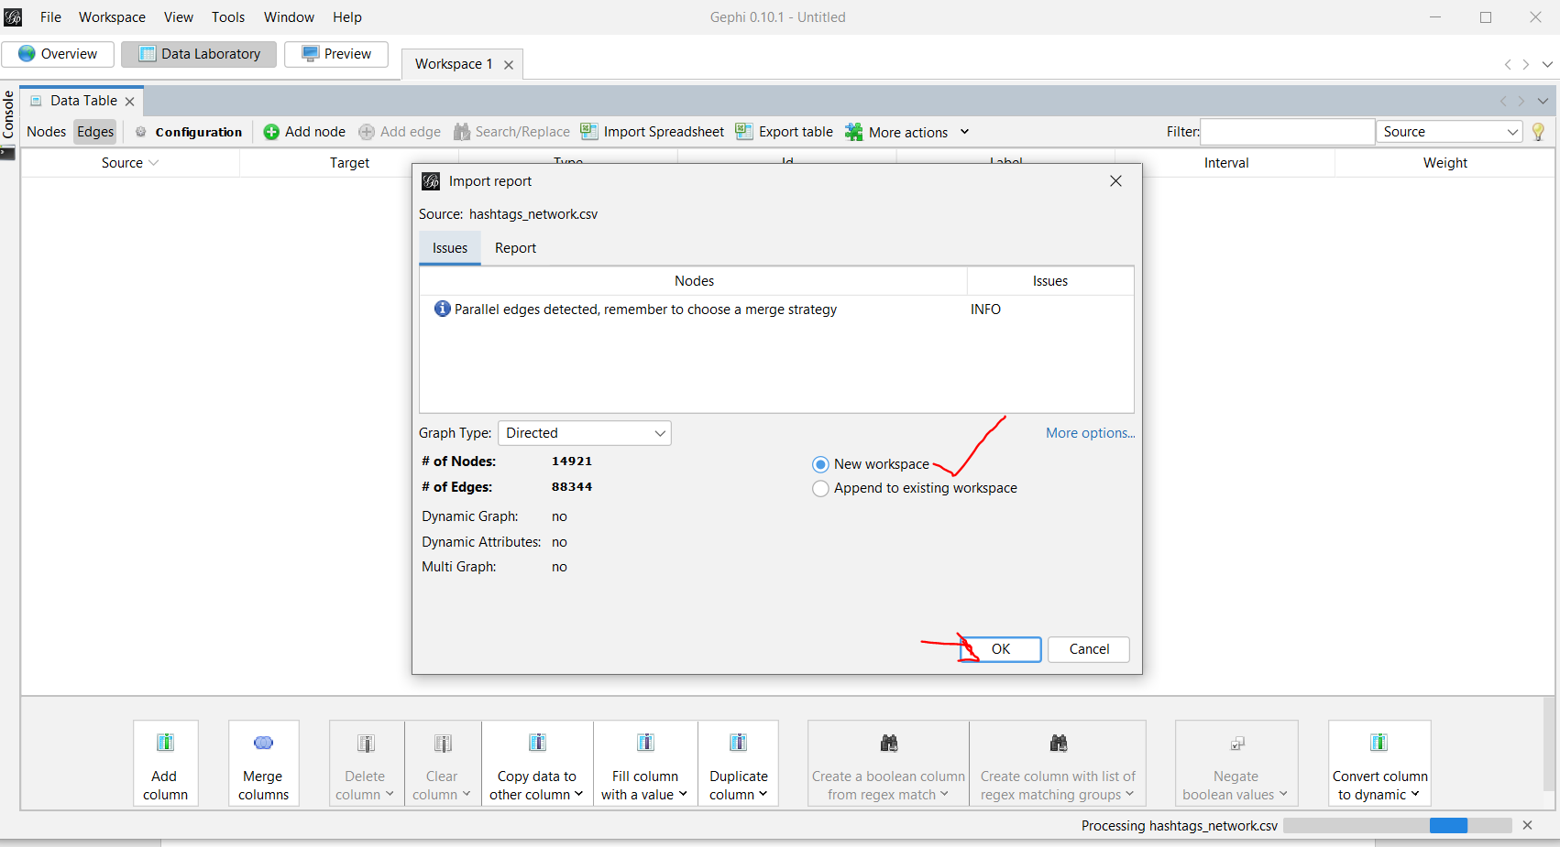

* Switch to the Overview tab to see the graph.
* Go to the Layout panel on the right side of the screen. If it’s not visible, enable it by going to Window > Layout.
* Choose a layout algorithm (e.g., "Force Atlas") and click Run to organize the graph visually.
* Adjust the settings as needed to improve visibility.
* Apply Degree Range Filter: Go to the "Filters" tab.
* Select "Topology > Degree Range" and drag it to the filter area.
* Adjust the degree range to focus on nodes with a higher degree.
* Click "Filter".
* Adjust Node and Edge Appearance:
* Go to the "Appearance" panel.
* Select "Nodes" and choose "Size" to adjust node size based on degree.
* Select "Edges" and choose "Thickness" to adjust edge thickness based on weight.
* Apply color schemes as needed.
* Finalize in Preview Tab: Switch to the "Preview" tab.
* Adjust settings for nodes, edges, and labels.
* Click "Refresh" to see the final visualization.
* For final adjustments and a polished look, switch to the "Preview" tab.
* In the Preview settings, you can fine-tune the appearance of nodes, edges, labels, etc.
* Click "Refresh" to see the changes in the preview window.

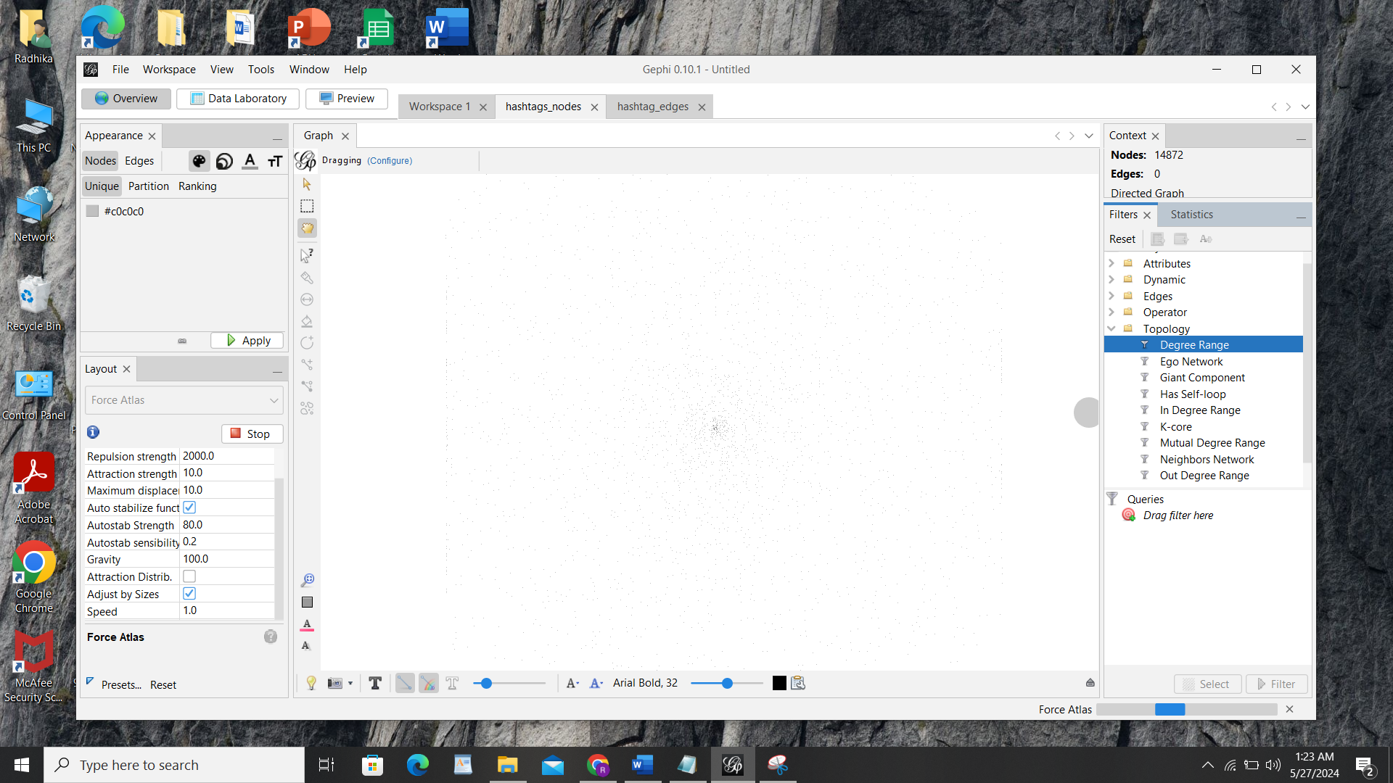

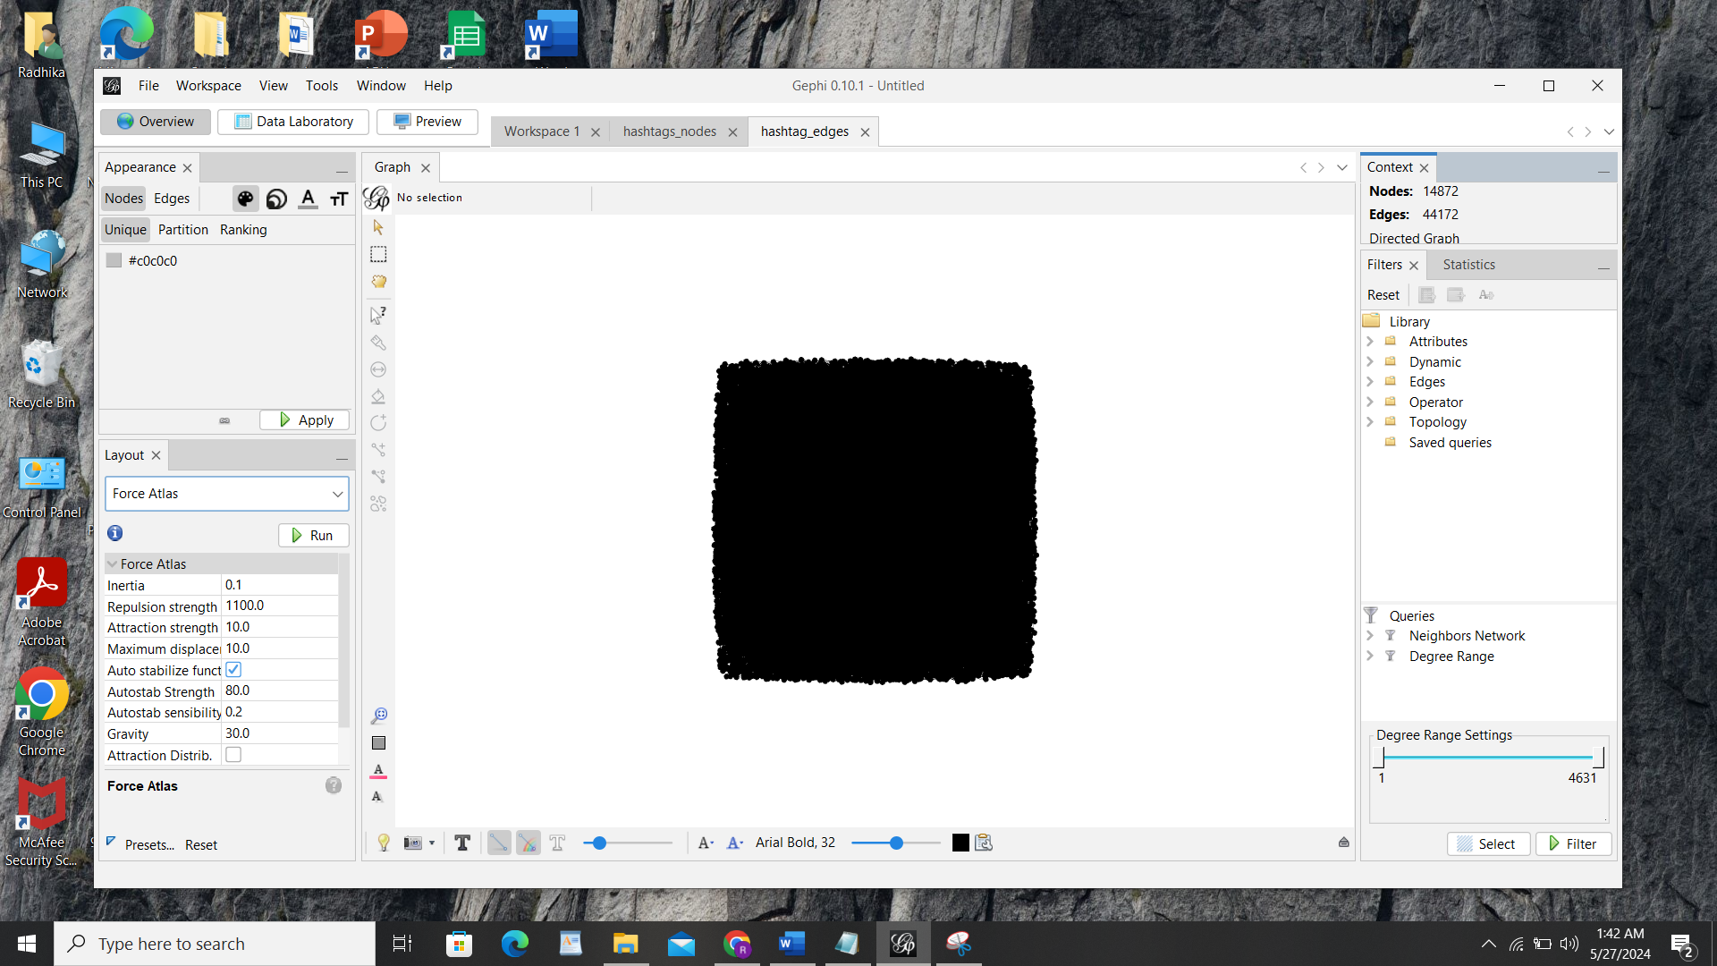

Select Layout “Yifan Hu”>> Click on Run and stop as you want.

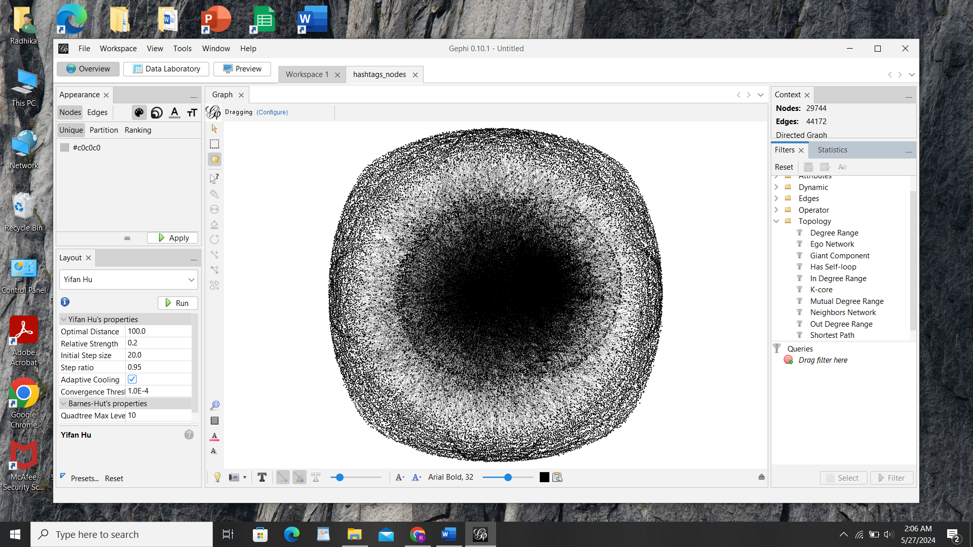

Go to Filter tab at right side panel and click on topology >>Drag Giant Component in queries section >>Click on Filter Button>>it will remove less important nodes>>

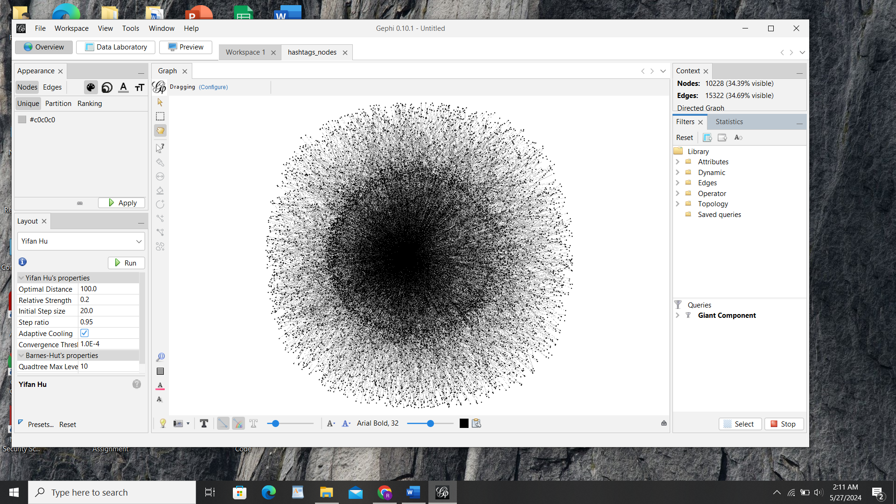

Now Again Run Layout algorithm “Yifan Hu” for getting your nodes clearly visible >> It is showing a fan like structure which means it has hubs >>connected with a degree of one

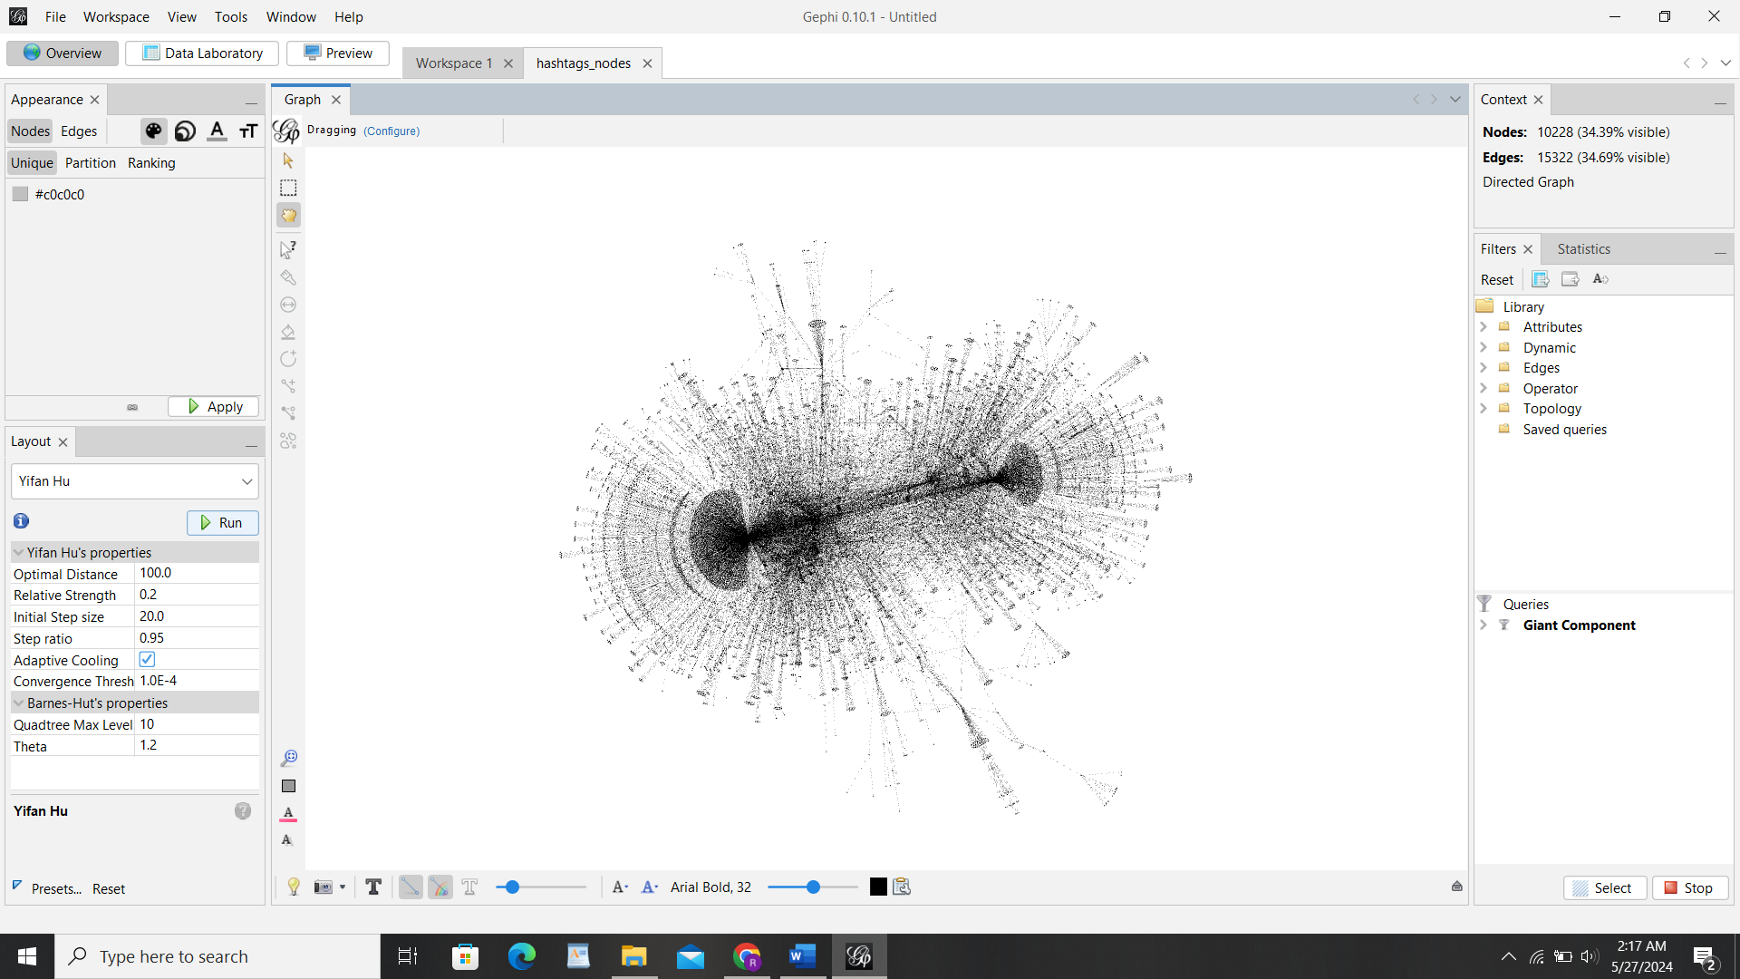

Now Drag Degree Range filter into sub filter of Giant Component>>Select Range as 2 It will gives us much more manageable network >> Run again the yifan hu algorithm >> Network is going to contract and layout into a much more reasonable shape.

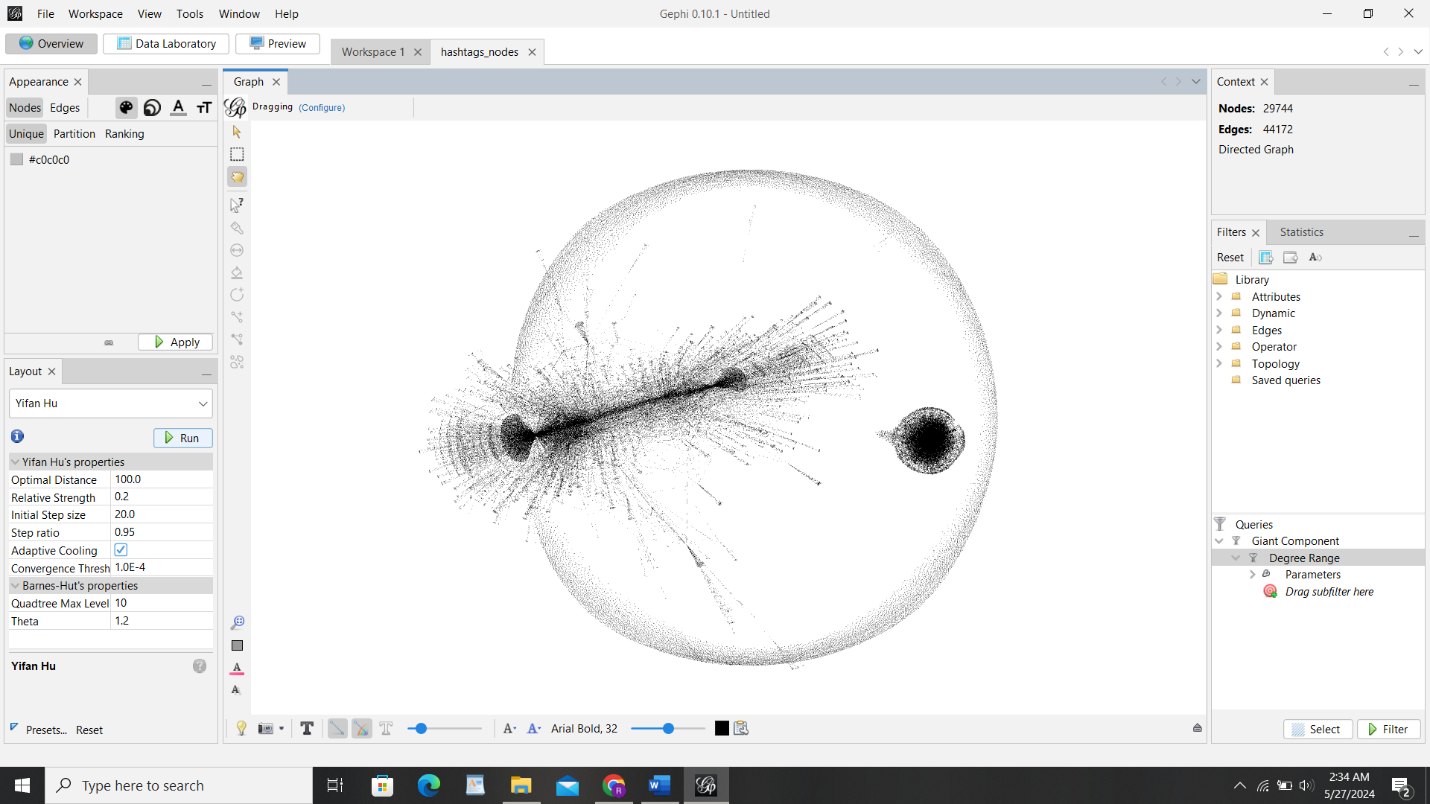

Go to statistics>>Click on Network diameter it will show you betweenness centrality and other centrality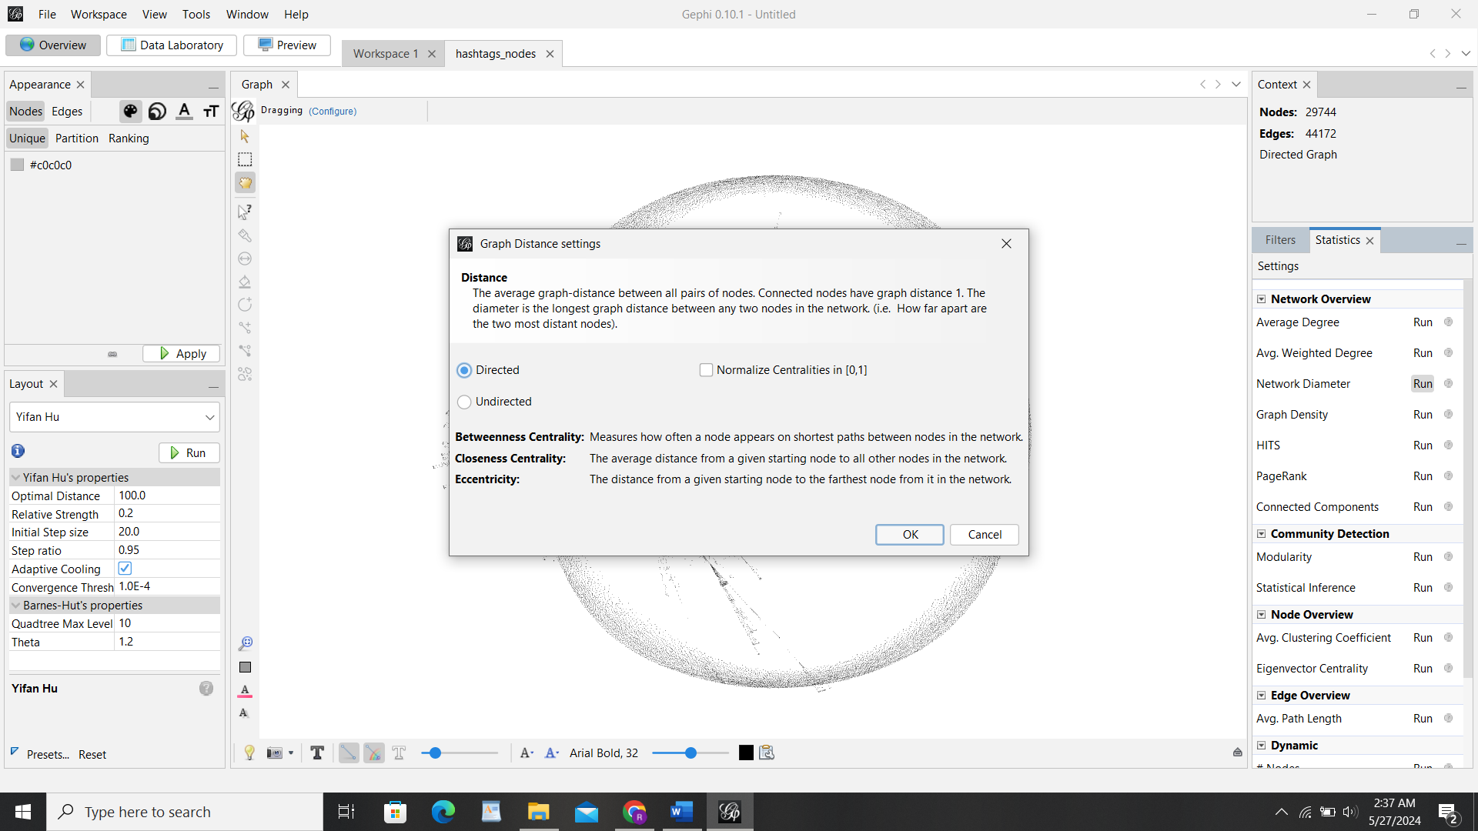

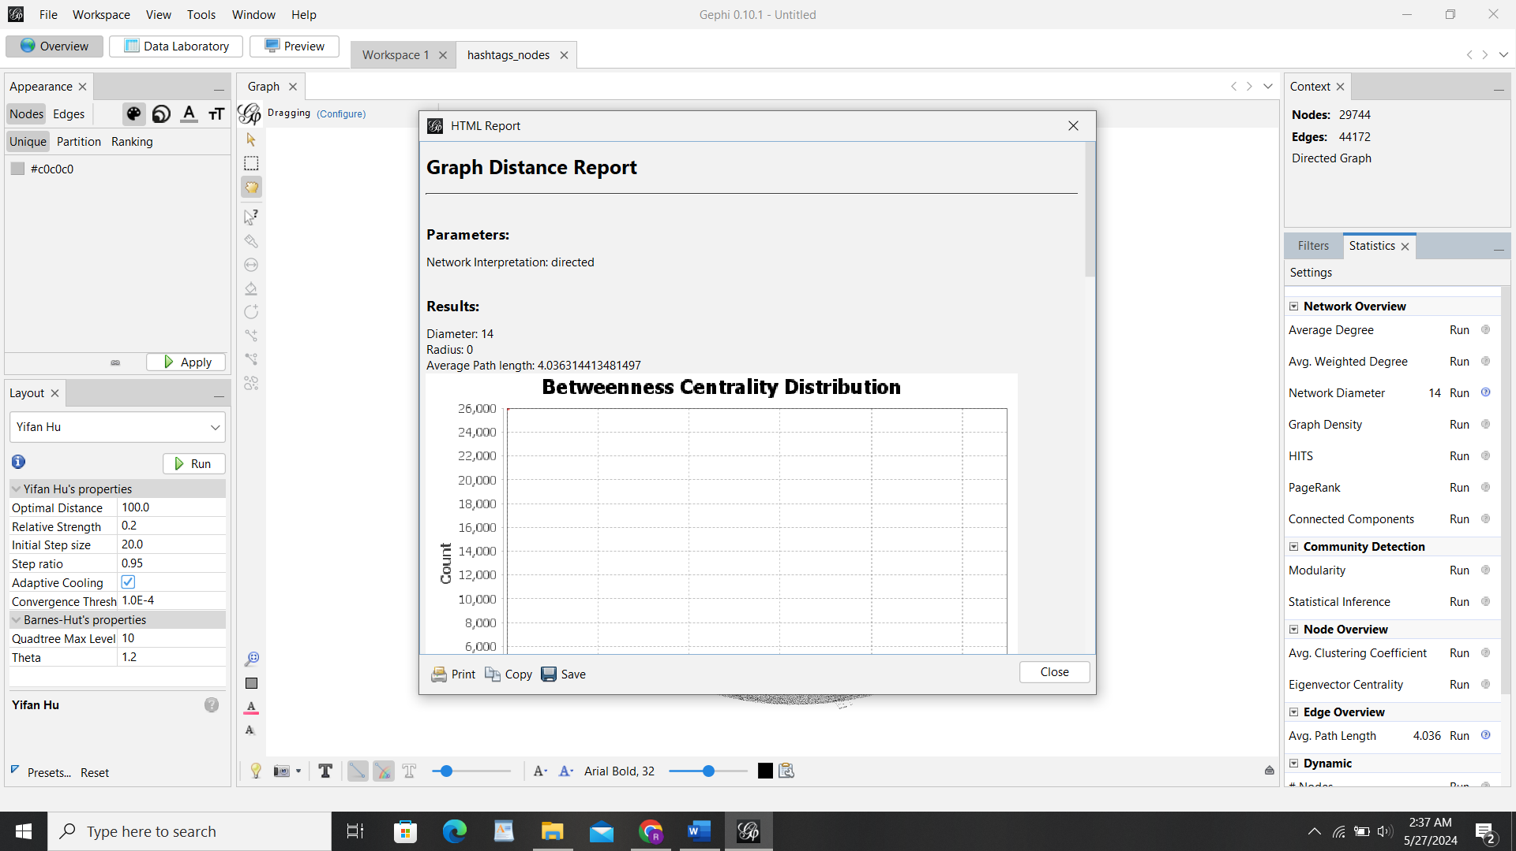

Now Finally run the modularity >>Enter the value as 5 in resolution >>click okay it will show you number of communities report

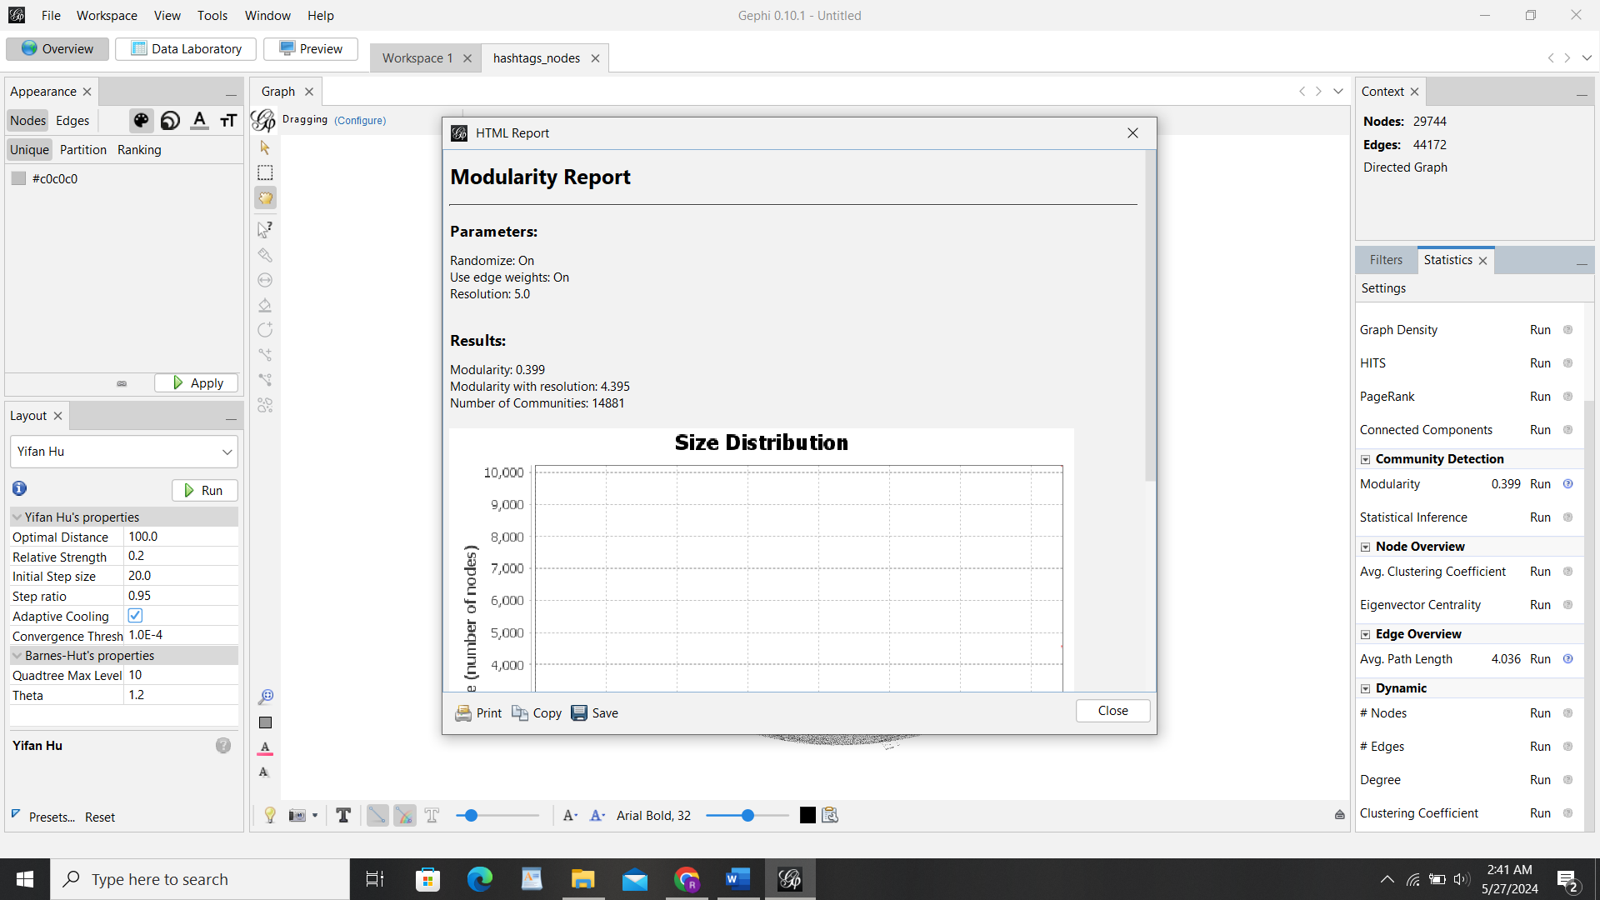

Now for visualization>>Go to Appearance tab>>Nodes>>Partition>>Modularity Class >>click apply>>it will show the clustering with colors >> go to size symbol>>Ranking>>Select Betweenness Centrality -min size 15 to max size 80>>Apply

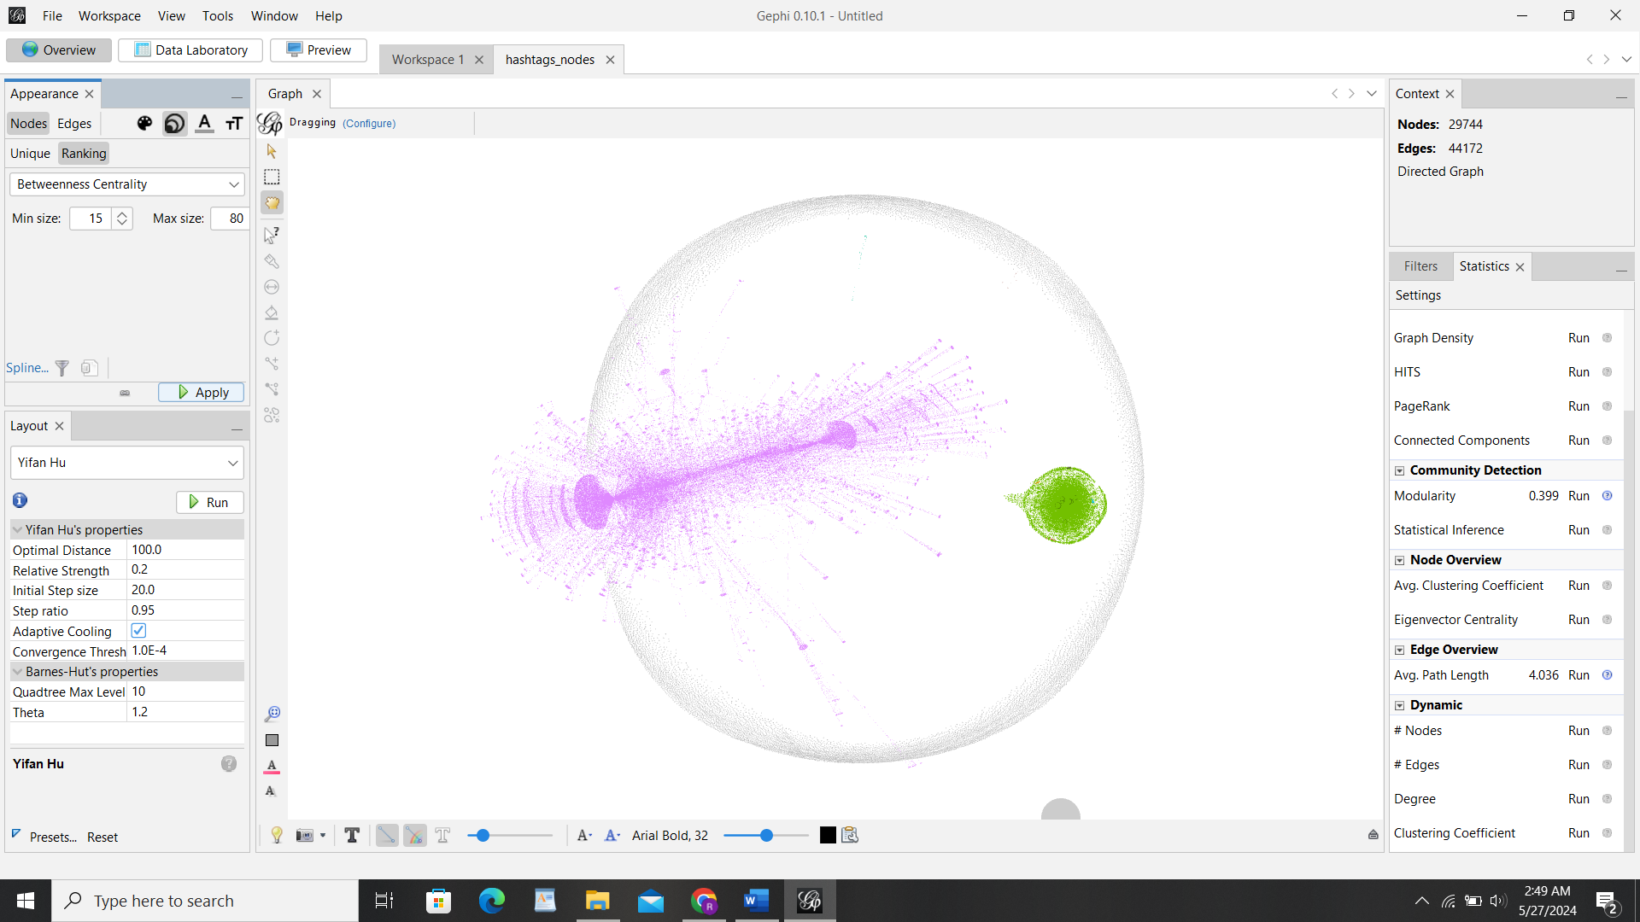

Click on Preview >> Adjust your nodes labels and edges level settings

